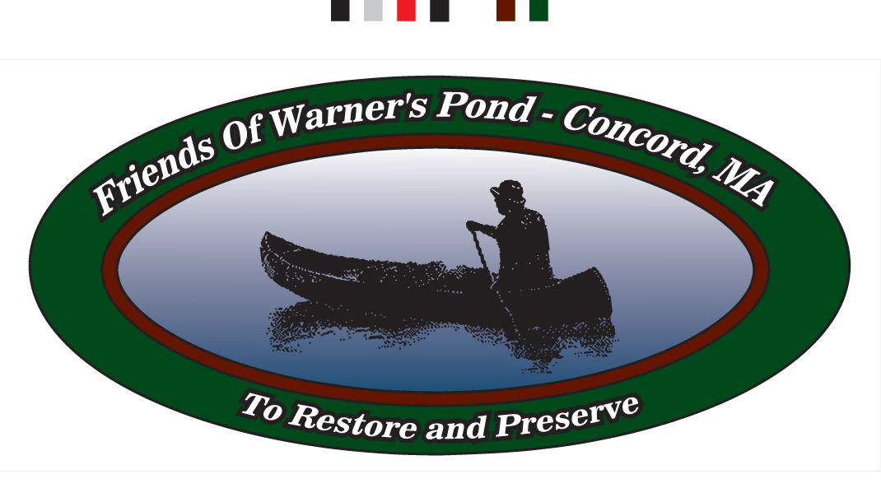

Donations

The Warner’s Pond Stewardship Committee, a subcommittee of the Natural Resource Commission, requires your help in the revitalization of Warner’s Pond. Funds are needed to rid the Pond of invasive non-native aquatic species, such as fanwort and milfoil that are growing on the bottom and threaten to choke out those species that are native to the pond. With your help, our end goal is to restore the natural habitat and return recreational activities to the Pond for the enjoyment of Concord’s citizens.

Our financial goal, at this time, is to assist the Town by matching funds to cover costs for two herbicide applications in Warner’s Pond. In an agreed combined effort, the DEP and Natural Resources Commission approved permitting for the Dam Repair and required 3 herbicide applications to be covered by the Concord Public works (CPW). We plan to put matching funds aside to cover the cost of the last two herbicide applications.

In addition to raising funds for the herbicide treatments, The Division of Natural Resources needs a water quality testing kit and a dissolved oxygen meter that measures the oxygen content in the water. These tools will help in testing to improve the quality of the water in Warner’s Pond, but also service the Town well and be shared to analyze water in all Concord’s local ponds and rivers.

Our website is a work in progress and soon will be set up to provide everyone the opportunity to donate online. To help you contribute now, please reference the information below:
Your donation can make the difference!
Please contribute to the success of this program by issuing a check to “Friends of Warner’s Pond” and submit it to the address below. We gratefully accept all donations. Thank you.

___$10 ___ $25 ___$50 ___$75 ___$100 ___Other

Please Make checks payable to:"Friends of Warner's Pond"

Please send your contribution to:
Friends of Warner’s Pond
P.O. Box 1272
Concord, MA 01742-1272

